TALONS
GMC Knowledge



Air Force ROTC Detachment 157
EMBRY-RIDDLE AERONAUTICAL UNIVERSITY
Fall 2025

“As Airmen, you must think differently about how we fly, fight and win. With accelerate, change, or lose, you need to think about the speed, the agility, the lethality we have that are force multipliers. You must adapt. And we cannot do this by ourselves. In order to be successful, we have to work together.”

-General Charles Q. Brown

Fall 2025 GMC Academic Syllabus

Quiz | Date | Knowledge
Quiz 1 | 5 September | Seven Basic Responses AF & SF Core Values
Quiz 2 | 12 September | Det 157 Cadre Customs and Courtesies
Quiz 3 | 19 September | Chain of Command
Quiz 4 | 26 September | AFROTC Ranks  Officer Ranks
Quiz 5 | 3 October | Small Unit Tactics  Rules of Firearm Safety
Quiz 6 | 10 October | TCCC  IED/UXO Procedures
Quiz 7 | 24 October | Air Force Enlisted Ranks  Space Force Enlisted Ranks
Quiz 8 | 31 October | Airman’s Creed
Quiz 9 | 7 November | ASFCs
Quiz 10 | 14 November | Air Force Song  Space Force Song
Quiz 11 | 21 November | CUMULATIVE TEST

GMC Canvas quizzes will be taken once a week during Friday PT.

Table of Contents
Fall 2025 GMC Academic Syllabus 3
Seven Basic Responses 6
Cadet Honor Code 6
Core Values 7
Missions 8
Mottos 8
Chain of Command 9
Detachment 157 Cadre 10
Customs and Courtesies 11
AFROTC Ranks 12
Officer Ranks 13
Small Unit Tactics 14
Unit Formation 14
Firearm Safety 22
React to Ambush 23
Bounding Overwatch 25
Hand & Arm Signals 26
TCCC 27
Phases of care 27
M.A.R.C.H. 27
IED/UXO Procedures 30
5-Cs (Confirm, Clear, Cordon, Check, Control) 31
Air Force Enlisted Ranks 32
Space Force Enlisted Ranks 33
Airman’s Creed 34
Air Force Specialty Codes (AFSC) 35
Air Force Song 37
Space Force Song 38
Stress Management as GMC and Future Officers 39

Why Is This Information Important?
Knowing basic information about the Air Force is crucial for aspiring members, at any level.
Here’s why:
Preparation: Understanding the basics, such as drill commands and uniform standards, helps you prepare for training. It makes your transition smoother, as you're already familiar with key concepts and procedures.
Shows Commitment: By learning about the Air Force in advance, you demonstrate your dedication and seriousness. This effort reflects your dedication to becoming a member of the Air Force and prepares you for the challenges ahead.
Reduces Stress: Basic knowledge helps reduce anxiety and uncertainty. Knowing what to expect can make initial training less overwhelming and helps you adapt more quickly.
Builds Discipline: Familiarity with Air Force protocols teaches discipline early on. This foundational understanding is crucial as discipline is a core value in military life.
Boosts Confidence: Being informed boosts your confidence! It prepares you mentally and helps you perform better in both training and future duties.
In summary, even a basic understanding of Air Force principles and procedures lays the groundwork for a successful and smooth transition into military life. It shows commitment, builds discipline, and boosts confidence—essential qualities for any aspiring Air Force members.

Seven Basic Responses

- Yes sir/ma'am
- No sir/ma'am
- No excuse, sir/ma'am
- Sir/ma'am, may I make a statement
- Sir/ma'am, may I ask a question
- Sir/ma'am I do not understand
- Sir/ma'am I do not know

Cadet Honor Code

We will not lie, steal, or cheat, nor tolerate among us anyone who does.

The Purpose of the Honor Code is to foster an environment based upon a personal sense of honesty and integrity. Implementation of the Honor Code means not only can you be trusted but that you also have the moral courage to confront those who violate these standards.

Core Values

Air Force Core Values

Integrity First Service Before Self
Excellence in All We Do

“There is no limit to the good you can do if you don’t care who gets the credit.”
General George C. Marshall

Space Force Core Values

Character, Connection, Commitment, and Courage

“Bottom line, we must protect space… It underpins every instrument of national power — diplomatic, information, military and economic.”
General John W. Raymond

Missions

USAF Mission: To fly, fight, and win... airpower anytime, anywhere.

USSF Mission: Secure our Nation's interests in, from, and to space.

AFROTC Mission: Develop Air and Space Force leaders of character whom we expect to fight and win our Nation's wars.

Holm Center Mission: We Build Leaders.

Detachment 157 Mission: To commission the most prepared and driven second lieutenants in the U.S. Air Force or Space Force.

Mottos
USAF Motto: Aim High … Fly-Fight-Win.
USSF Motto: Semper Supra “Always Above”

Chain of Command

Commander-in Chief: The Honorable Donald J. Trump

Secretary of Defense: The Honorable Peter B. Hegseth
Secretary of the Air Force: The Honorable Troy E. Meink

Chairman of the Joint Chiefs of Staff: Gen John D. Caine.

Chief of Staff of the Air Force: Gen David W. Allvin

Chief of Space Operations: Gen B. Chance Saltzman

AETC Commander: Lt Gen Brian S. Robinson

Air University Commander: Lt Gen Andrea D. Tullos

Holm Center Commander: Brig Gen Joseph L. Sheffield

AFROTC Commander: Col Eugene A. Moore III

Southeast Region Commander: Col Aaron L. Ruona

Det 157 Commander: Col Gregory M. Adams

Det 157 Operations Officer: Lt Col Nicolas Wright

Detachment 157 Cadre

Cadre AFSC Detachment Role

Col Gregory Adams 11M Commander

Lt Col Joseph Pugliese 13H Director of Staff

Lt Col Nicolas Wright 11H Operations Officer

Maj Nicole Augins. 21R Assistant Operations Officer

Maj Joseph Niez 12B Education Officer

Capt Abigail Black 14N Assistant Recruiting Officer

Capt Alaura Holt 38F Admin OIC

Capt Vance Mathis 63A Recruiting Officer

TSgt James Hillegas 3E471 Admin NCOIC

SSgt Danielle Black. 3F5 Administration

SSgt Darryel Gate 3F5 Medical NCO

SSgt Logan Whitehill 3F5 Personnel Manager

Customs and Courtesies
In the Air Force, saluting and greeting higher-ranking officers are vital for maintaining respect and professionalism. Here's why these practices are important:
- Respect and Professionalism: Saluting and using “Yes, Sir” or “Yes, Ma’am” demonstrate respect for the rank and authority of others. This form of address reinforces the respect and discipline that are fundamental in the Air Force, highlighting the hierarchical structure and ensuring that interactions remain respectful and professional.
- Saluting Etiquette: Saluting is performed outdoors and only when within six paces of an officer. This tradition ensures that salutes are given in a controlled and respectful manner, reflecting proper military decorum. Indoors, saluting is not required, but you should still greet and address officers with respect.
- Timing of Salutes: Salutes are exchanged based on the time of day:
  - Morning: From 0000 (midnight) to 1159 (11:59 AM), use “Good morning.”
  - Afternoon: From 1200 (noon) to 1659 (4:59 PM), use “Good afternoon.”
  - Evening: From 1700 (5:00 PM) to 2359 (11:59 PM), use “Good evening.”
- Addressing Groups: When addressing a group of officers, use “Ladies and Gentlemen” to cover all attendees respectfully.
- Order of Address: “Ma’am” should be used before “Sir”.
These protocols ensure that all personnel maintain a high standard of respect and professionalism, reflecting the values and structure of the Air Force.

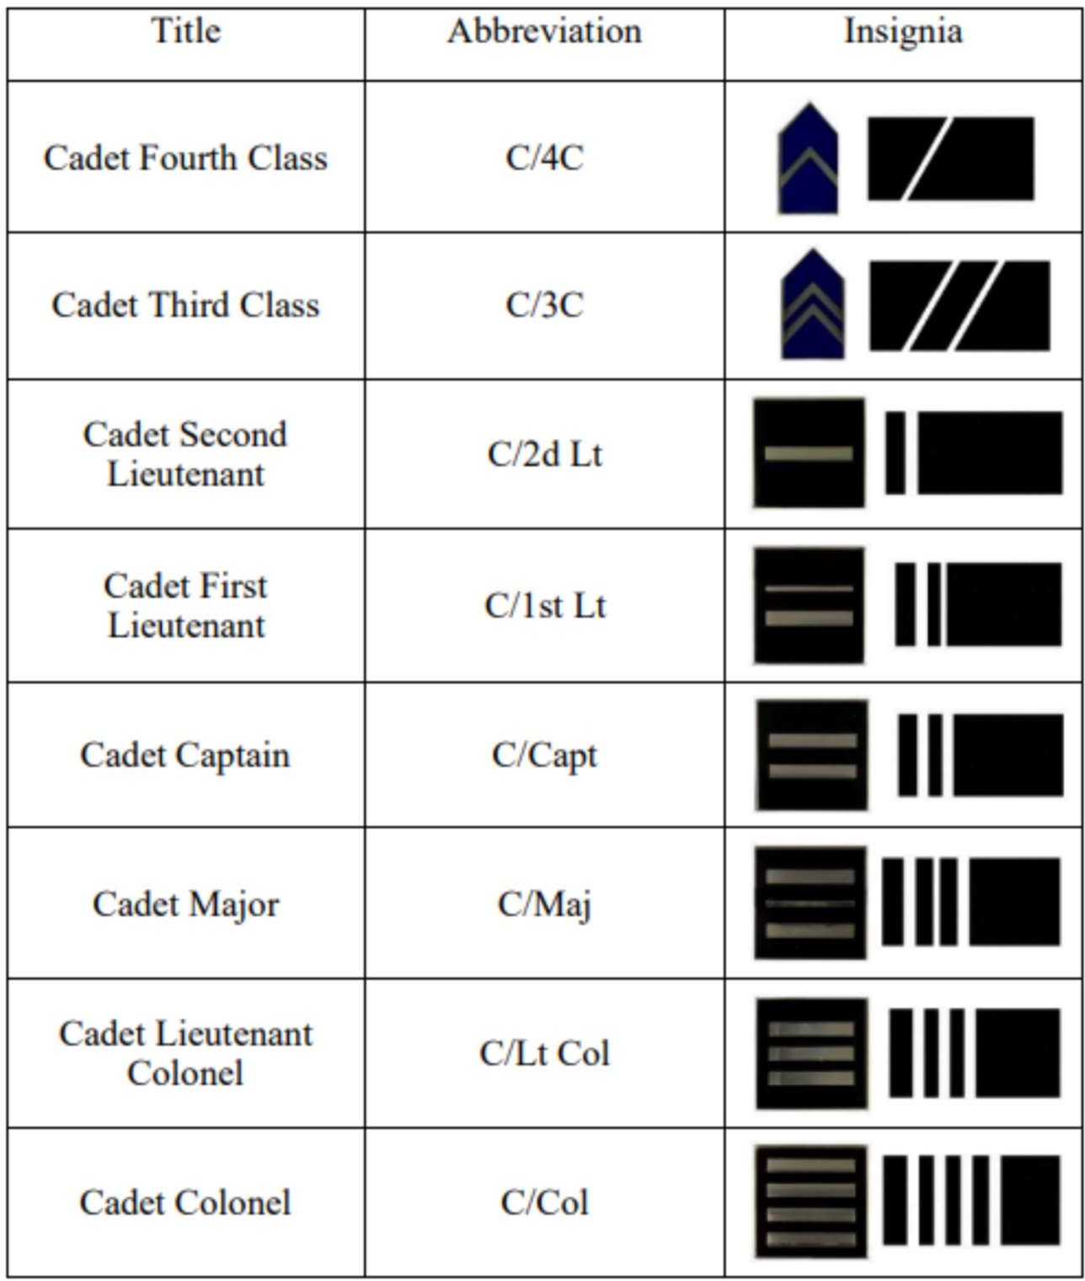
AFROTC Ranks

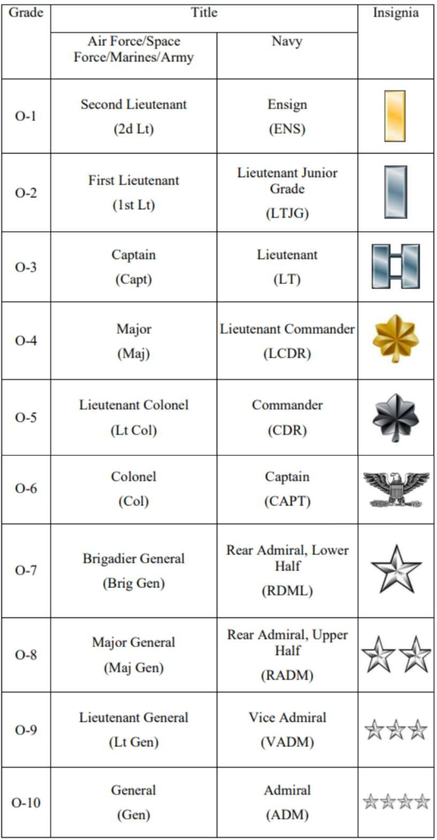
Officer Ranks

Small Unit Tactics

Unit Formation
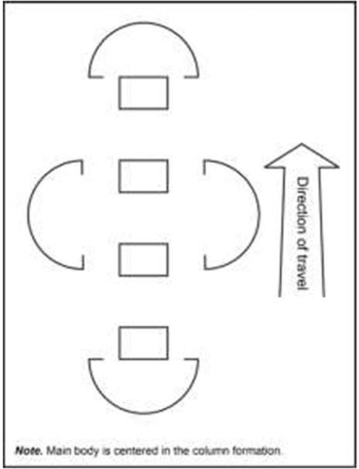
Column Formation: The column formation is a movement formation with elements arranged one behind another. A unit moves in column formation when the unit does not anticipate early contact, the objective is distant, and speed and control are critical. The location of direct fire systems within the column reflects the column’s length and the range fans of those systems. Normally, the lead element uses a traveling overwatch technique while the following units are in traveling formation. A column formation—
- Provides the best formation to move large forces quickly, especially with limited routes and limited visibility.
- Makes enemy contact with a small part of the total force while facilitating control and allowing the unit to quickly mass forces.
- Provides a base for easy transition to other formations.
- Works in restricted terrain.

There are also disadvantages to using a column formation, these include-
- Units can only immediately apply most of the column’s firepower on the column’s flanks.
- The length of the column affects movement and terrain management.
- Possibly inadvertently bypassing enemy units or positions and exposing the unit’s flanks.
- Running head-on into an enemy deployed perpendicular to the column’s direction of movement.
Restricted terrain may limit the ability of friendly forces to maneuver if contact is made to the front of the formation.
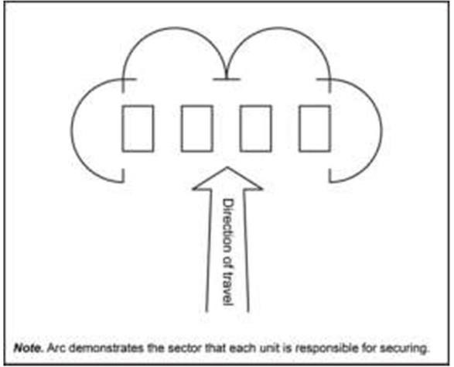
Line Formation: A line formation is a movement formation in which elements move abreast of each other. A unit typically employs this formation when assaulting an objective because it concentrates firepower to the front in the direction of movement. A line formation also—
- Facilitates speed and shock in closing with an enemy force.
- Allows the coverage of wide frontages.
- Facilitates the occupation of attack by fire or support by fire positions.
There are also disadvantages of a line formation:
- Provides less flexibility of maneuver than other formations since it does not distribute units in depth.

- Linear deployment allows a unit deployed on line to bring only limited firepower to bear on either flank.
- Provides limited or no reserve.
- Limits overwatch forces.
- Limits control of a unit using a line formation in restricted terrain or under conditions of limited visibility.
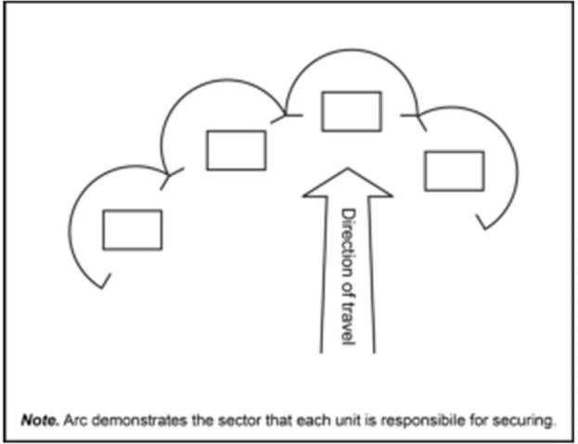
Wedge Formation: The wedge formation is a movement formation with one lead element and the trail elements are paired off abreast of each other on the flanks. Units use this formation to attack an enemy appearing to the front and flanks. Any unit can conduct a wedge formation; if there are an even number of maneuver elements, one side will be longer than the other. Leaders designate which side they want longer by directing a “heavy side.” For example, if a leader said they wanted the unit in a “wedge formation— heavy left,” then the left side of the unit would have more elements than the right side of the element. A unit uses the wedge when contact with an
enemy force is possible or expected, but the enemy force’s location and dispositions are vague. It is the preferred formation for a movement to
contact in an organization with three subordinate maneuver units because it initiates contact with one unit while retaining two other subordinate uncommitted units positioned to maneuver and further develop the situation. Within the wedge, subordinate units employ the formation best suited to the terrain, visibility, and likelihood of contact. Employing a wedge formation—

  - Provides maximum firepower forward and allows units to use a large portion of their firepower on the flanks.
  - Allows rapid crossing of open terrain when enemy contact is not expected.
  - Facilitates control.
  - Allows for rapid changes in the direction of movement.
  - Facilitates the rapid change to other movement formations. The primary disadvantages to the wedge formation are that it—
  - Requires sufficient maneuver space or multiple routes for dispersion laterally and in depth.
  - Lacks ease of control in restricted terrain or poor visibility.

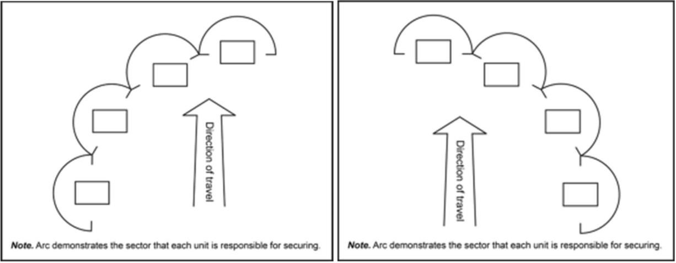
Echelon Formation: An echelon formation is a movement formation with elements arranged on an angle to the left or to the right of the direction of attack (echelon left, echelon right). This formation provides focused firepower forward and to the flank of the direction of the echelon. It facilitates control in open areas. It provides minimal security to the opposite flank in the direction of the echeloning. A unit with knowledge of potential enemy locations can use an echelon formation to deploy subordinate ground elements diagonally left or right or as a way to work within a higher echelon movement formation. Units operating on the flank of a larger formation commonly use this formation. An echelon formation—
  - Facilitates control in open terrain.
  - Allows the concentration of the unit’s firepower forward and to the flank in the direction of the echelon.
  - Allows forces not in contact to maneuver against known enemy forces because all elements will not simultaneously make contact.
The primary disadvantages of this formation are difficult to maintain control over the unit in restricted terrain.
  - Lacks security or firepower on the opposite side of the echelon.
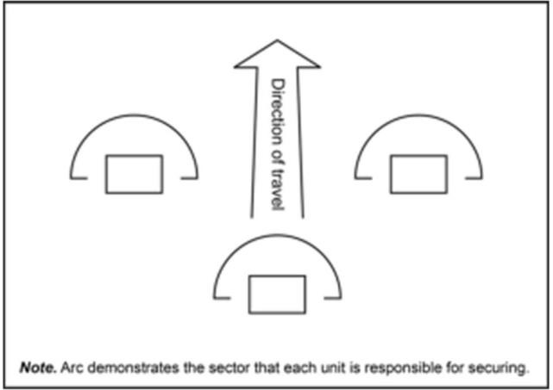
Vee Formation: A vee formation is a movement formation with two elements abreast and one or more elements trailing. If there are more elements after the trail element in the vee formation, the trail elements can be in front or behind the main body. This arrangement is suited for an advance against a known threat to the front. It—
  - Provides maximum firepower forward and good firepower to the flanks, but the firepower on the flanks is less than that provided by the wedge.
  - Facilitates a continued maneuver after making contact and a rapid transition to the assault.
  - Allows a unit to change quickly to a line, wedge, or column formation.
The primary disadvantages to this formation include:
  - Reorientation in the direction of movement, such as a 90-degree turn, are more difficult than using the wedge.
Control is difficult in restricted terrain and under limited-visibility conditions.
  - Lead element masks fires of the trail element.
  - Requires sufficient maneuver space for dispersion laterally and in depth.
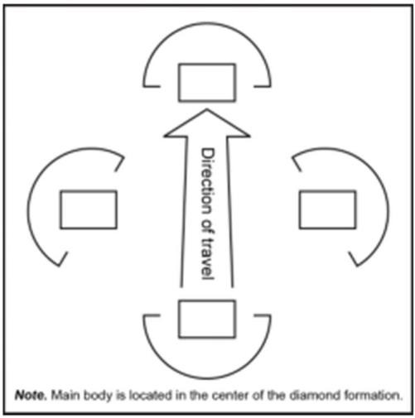
Diamond Formation: A diamond formation is a movement formation with one element leading, one element positioned on each flank, and the remaining elements to the rear. The non-security units of the diamond usually move in a column formation inside of the diamond. It is most effective during approach marches, exploitations, or pursuits when the unit has only general knowledge about the enemy.
Advantages of employing a diamond formation include—
  - Allowing units to maneuver to either flank immediately, regardless of which subordinate element makes enemy contact.
  - Facilitates making enemy contact with the smallest possible force yet provides all around security.
  - Provides firepower to the front and flanks.
  - Changes easily and quickly to another formation.
  - Facilitates speed of movement while remaining easy to control.
  - Provides an uncommitted force for use as a reserve. The primary disadvantages of this formation are that it—
  - Requires sufficient maneuver space or multiple routes for dispersion laterally and in depth.
  - Requires four subordinate maneuver elements.
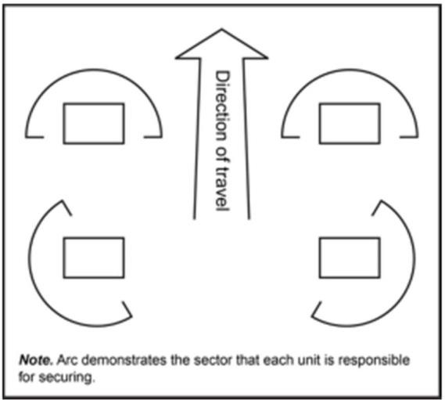
Box Formation: The box formation is a movement formation with elements arranged in a box or square, or two elements up and two elements back. This formation is only used when the unit has four security or combat elements. It is a flexible formation providing equal firepower in all directions. This formation can limit 50 percent of the force becoming decisively engaged simultaneously. The box formation arranges the unit with two forward and two trail maneuver elements.
Units with only three subordinate maneuver elements cannot adopt the box formation, you must have 4 or more. The subordinate elements of the box usually move in a column formation within the box formation. Units often use this formation when executing an approach march, exploitation, or pursuit when they have only general knowledge about the enemy. Employing a box formation—
  - Allows a unit to change quickly and easily to any other formation.
  - Facilitates rapid movement yet still provides all around security.
  - Provides firepower to the front and flanks.
  - Maintains control more easily than a line formation.
Using the box formation also has disadvantages. These include—
  - The requirement for sufficient maneuver space or multiple routes for dispersion.
  - The possibility exists of enemy units massing on one element at a time as the presence of other friendly forces can mask other
element’s direct fires.

“In every battle, there comes a time when both sides consider themselves beaten, then he who continues the attack wins.”
General Ulysses S. Grant, US Army

Firearm Safety

Rule #1 | Treat all weapons as loaded
Rule #2 | Never point a weapon at anything you do not intend to shoot
Rule #3 | Keep your weapon on SAFE until you are ready to fire (unless directed otherwise)
Rule #4 | Keep your finger off the trigger until sights are on target and you are ready to fire
Rule #5 | Positively identify your target, be aware of what is around and behind the target
Rule #6 | Never engage in horseplay while handling weapons

“Leadership is a responsibility to do more, not an excuse to do less.”
CSM Scott Schroeder, US Army

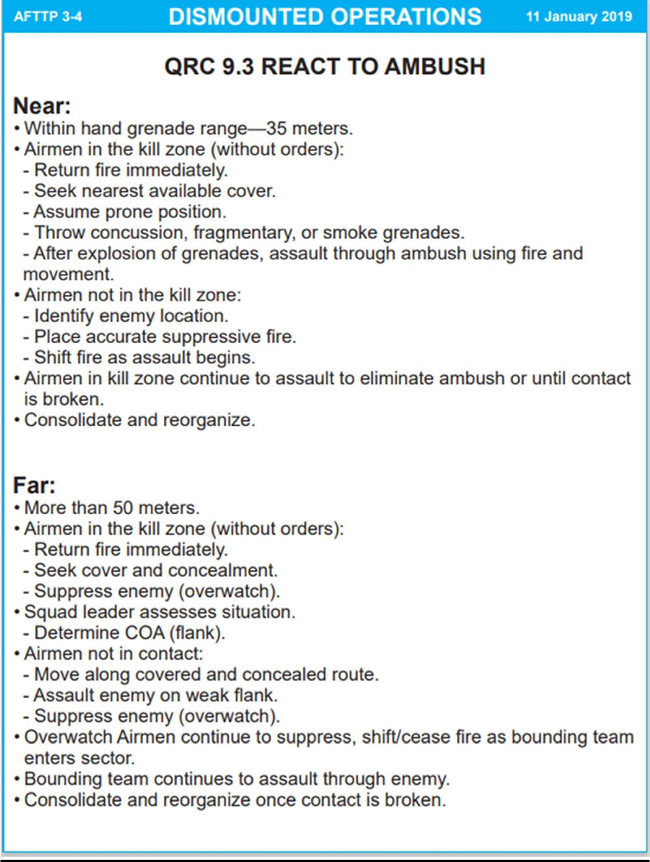
React to Ambush
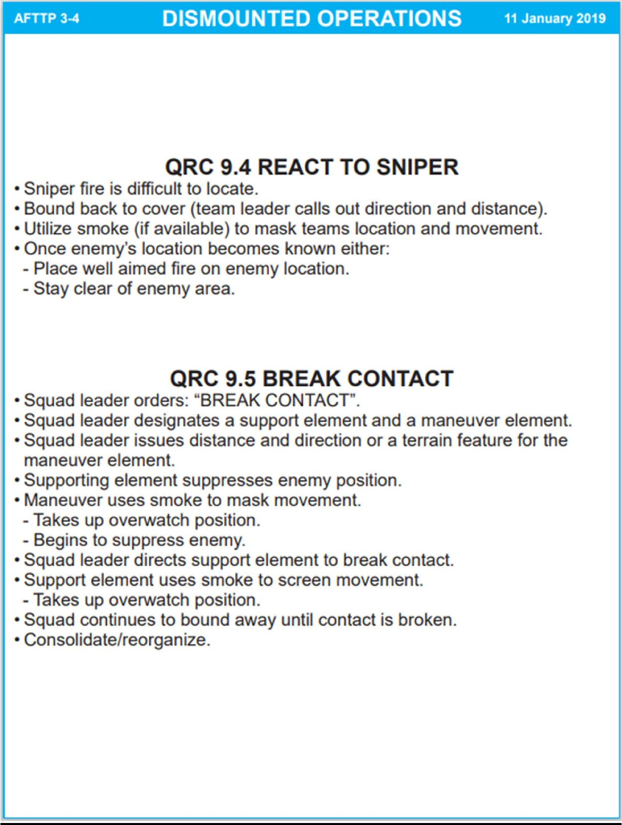

Bounding Overwatch
- Bounding overwatch is used when contact is expected, when the squad leader feels the enemy is near (based on movement, noise,
reflection, trash, fresh tracks, or even a hunch), or when a large open danger area must be crossed.
- The lead fire team overwatches first. Soldiers in the overwatch team scan for enemy positions. The squad leader usually stays with the overwatch team. The trail fire team bounds and signals the squad
leader when his team completes its bound and is prepared to overwatch the movement of the other team.
- Both team leaders must know which team the squad leader will be with. The overwatching team leader must know the route and destination of the bounding team. The bounding team leader must know his team's destination and route, possible enemy locations, and actions to take when he arrives there. He must also know where the overwatching team will be and how he will receive his instructions. The cover and concealment on the bounding team's route dictates how its Soldiers move.
- Teams can bound successively or alternately. Successive bounds are easier to control; alternate bounds can be faster.
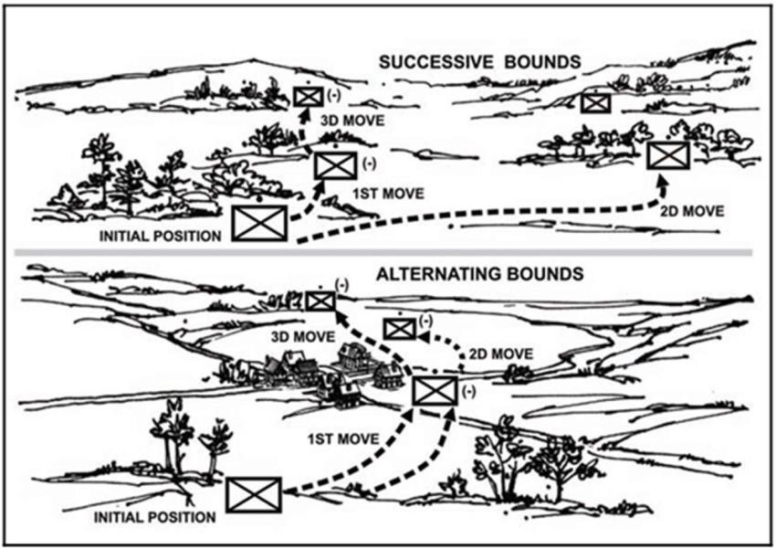

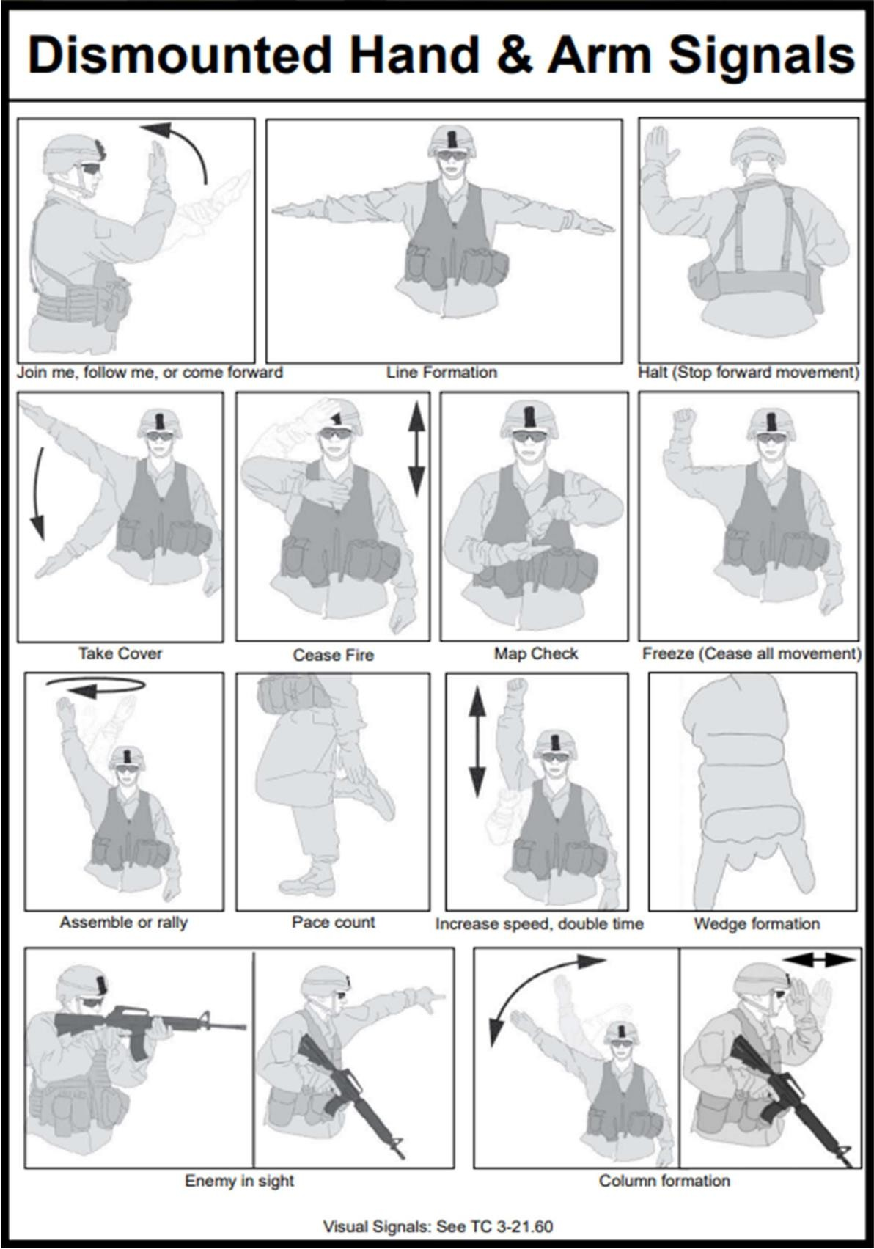
Hand & Arm Signals

TCCC

Tactical Combat Casualty Care (TCCC) is a response method used during battlefield or tactical environments. If used quickly and efficiently, TCCC reduces the number of preventable deaths.

**Before administering ANY life-saving care,
ensure the scene is SAFE. Constantly re-evaluate the scene.**

Phases of care
Care Under Fire (CUF): Care rendered at the scene while under hostile fire. Only immediate, life-saving interventions can be performed. Medical equipment will be limited.
Tactical Field Care (TFC): Care that is provided once the immediate threat of hostile fire has ceased.
Tactical Evacuation Care (TACEVAC): Care rendered during transport to a higher level of care.

M.A.R.C.H.
When caring for a patient during TCCC, remember the acronym M.A.R.C.H. Performing only part of this process may be necessary to protect yourself or the patient from hostile fire. If this is the case, remember to begin treatment from the beginning of the acronym.
M (massive bleeding) management is typically the only treatment that can be administered during CUF.

Massive hemorrhage/bleeding
Airway
Respirations
Circulation
Hypothermia/head injury

Massive hemorrhage: For life-threatening bleeding from an extremity, place a tourniquet “high and tight”. Ideally, a tourniquet is applied within 30 seconds. Write the application time on the tourniquet or patient’s forehead. Extremities may also be packed with combat gauze and hemostatic dressing. DO NOT pack wounds on the torso or chest. Apply a hemostatic dressing or chest seal instead. DO NOT attempt to place exposed internal organs back in the patient.
Airway: If the patient is conscious and talking, consider their airway open and move to the next step. If the patient is unconscious, check for an obstructed airway using head-tilt-chin-lift or the jaw thrust methods. If you can see the obstruction, carefully remove it (do not “blind sweep”). If the airway is obstructed due to a trauma or burn, take note for medical personnel, and move to the next step.
Respirations: Look, listen and feel for casualty’s breathing. Identify what might cause irregular breathing patterns, sucking chest wounds, tension pneumothorax, and shock are likely. Apply a chest seal, perform a needle decompression, or treat shock accordingly.
Circulation. If the casualty’s organs are not receiving enough oxygen, they will likely experience shock. Shock is a life-threatening condition that may lead to organ damage and death. Symptoms include cool, clammy, pale skin, weak or rapid pulse, shallow breathing, dizziness, and altered mental status. If shock is suspected, check prior tourniquet or dressing applications. DO NOT adjust initial tourniquet. Apply a second tourniquet immediately below the first.
Head injury/hypothermia. A patient experiencing shock is likely to be hypothermic. First, remove any cold sources. Remove wet clothing (this includes blood-soaked clothes). Place materials between the patient and the ground. Place a space blanket on top of the patient.

Repeat M.A.R.C.H as needed. Remember to constantly re-evaluate the scene, patient’s breathing and any care which was rendered prior.

IED/UXO Procedures

IED – Improvised Explosive Device(s). A homemade bomb and/or destructive device to destroy, incapacitate, harass, or distract.
UXO – Unexploded Ordinance. Undetonated munitions or explosive devices which may still be considered at risk of detonation.
EOD – Explosive Ordinance Disposal.

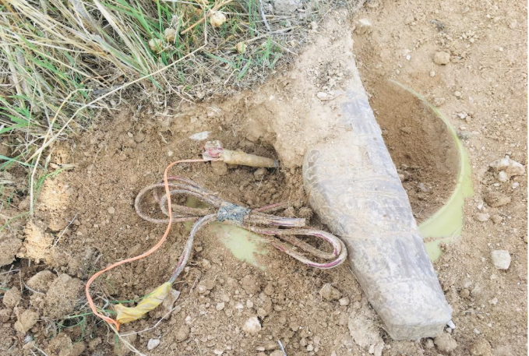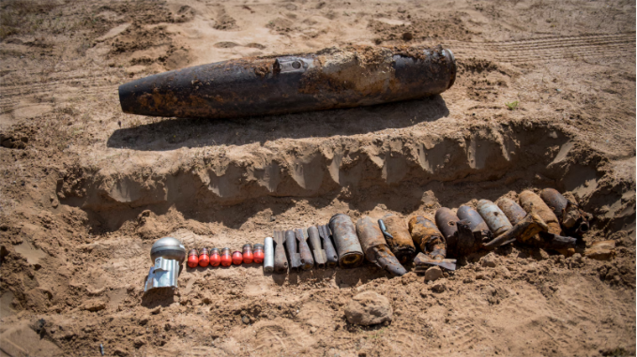

5-Cs (Confirm, Clear, Cordon, Check, Control)

If an IED is found or detonated, conduct the 5-Cs.

Confirm – Is this object a UXO/IED? Why? -- VISUAL: Disturbed Earth, signs of wire/string. DANGER AREAS: Previous IED Sites, Choke point (narrow passage), blind spot, IED tip from locals to the area – may have information on potentially hazardous areas.
Clear – Clear personnel out of the area and nearby buildings (300 meters if possible).
Cordon – Cordon or rope off the area using mine tape, warning tape, or rope. Nobody passes the cordon.
Check – Sweep the area for any secondary devices around the site.
Control – Help EOD team with area control. Do not allow anyone else to touch or move the UXO/IED.

Air Force Enlisted Ranks
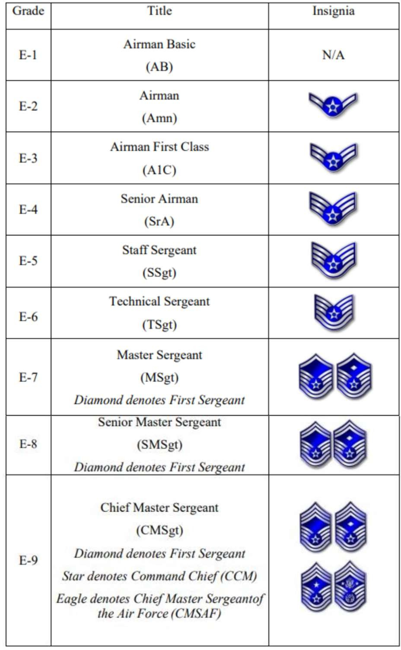

Space Force Enlisted Ranks
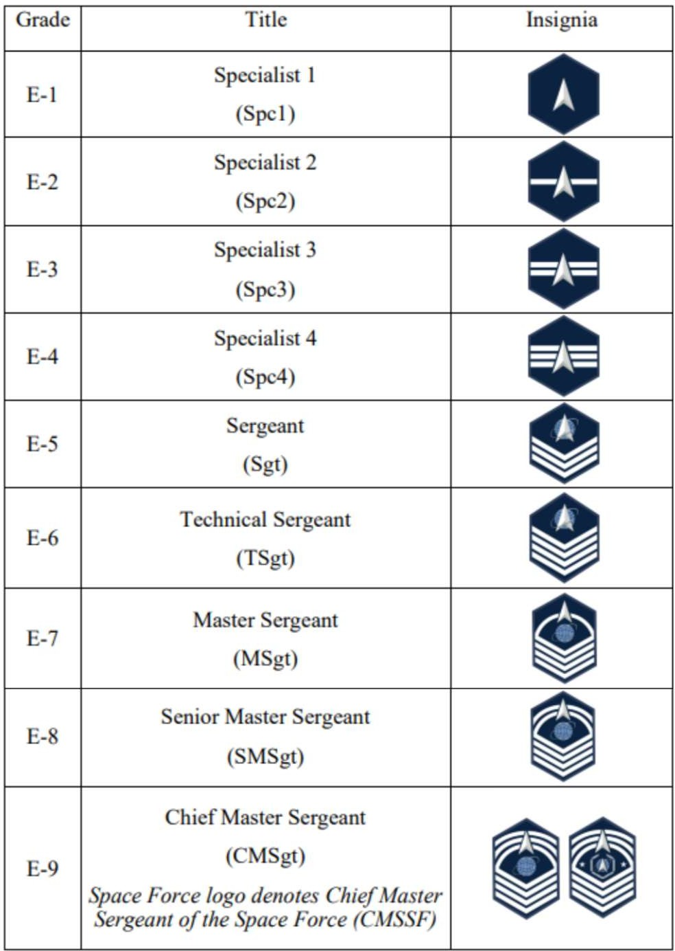

Airman’s Creed
I am an American Airman.
I am a Warrior.
I have answered my Nation’s call.

I am an American Airman.
My mission is to Fly, Fight, and Win.
I am faithful to a Proud Heritage,
A Tradition of Honor,
And a Legacy of Valor.

I am an American Airman.
Guardian of Freedom and Justice, My Nation’s Sword and Shield, Its Sentry and Avenger.
I defend my Country with my Life.

I am an American Airman. Wingman, Leader, Warrior.
I will never leave an Airman behind,
I will never falter,
And I will not fail.

Air Force Specialty Codes (AFSC)

11X | - Pilot  - Fly missions in multitude aircraft types (trainers, bombers, fighters, mobility, helicopters, surveillance, etc.)  - Leads flight crew and ensures mission accomplishment
12X | - Combat Systems Officer (CSO)  - Operates navigation, weapons systems, surveillance systems, electronic warfare systems, etc.  - Work onboard multitude of specialized aircraft or with RPA
13B | - Air Battle Manager (ABM)  - Control and sequence aircraft over a given battlespace  - Utilize multiple air assets to determine outcome of a battle
13H | - Aerospace Physiologist  - Plan, execute and supervise training and operational programs  - Research deep into the complex and unique field of physiology, human factors and human performance  - Provide comprehensive training on the threats, hazards and risks of Air Force operations and their mitigating strategies  - Provide educational training in a variety of Air Force classes
13M | - Airfield Operations  - Perform and lead airfield operations (AO) teams of Air Traffic Control (ATC), Airfield Management (AM), and Radar, Airfield, and Weather Systems (RAWS) Airmen within national and international, peacetime and combat environments  - Advise commanders on the effective use of AO assets
13N | - Nuclear and Missile Ops  - Monitor and control nuclear and missile operations  - Coordinate nuclear and missile operations policy, activities and programs
13S | - Space Operations  - Encompasses operating and managing systems involved in space  surveillance, space lift, ballistic space warning, and satellite command and control  - Manage space flight planning, training and mission control, along with launching and recovering spacecraft.
14X | - Intelligence  - Collect, interpret and act upon collected data to brief mission leaders  - Establish viability of missions and advise on mission execution, give orders to execute missions on targets or threats

17X | - Cyberwarfare  - Monitor cyber threats to national security  - Manage offensive and defensive cyber capabilities to thwart adversarial threats
19Z | - Special Tactics  - Special Tactics Officer (STO), Combat Rescue Officer (CRO), Tactical Air Control Party Officer (TACP-O)  - Conduct combat and rescue missions in cooperation with joint forces
21A | - Aircraft Maintenance Officer  - Direct aircraft maintenance and reparation activities  - Formulate maintenance plans and conduct periodic inspections
21R | - Logistics Readiness Officer  - Compute and analyze current and projected materiel requirements  - Direct distribution management operations, contingency, fuel management, aerial port and vehicle management operations
31P | - Security Forces Officer  - Lead and organize security forces operations to include leading airmen and managing posts, training activities and base / asset security  - Protect nuclear, missile, aircraft, infrastructure and Air Force personnel
62E | - Developmental Engineer  - Conduct design studies and manage studies contracted to subcompanies, while coordinating engineering and technical managing activities  - Continuously analyze technical policies and procedures, products and services to improve customer support
63A | - Acquisitions Manager  - Oversee and manage acquisitions projects for aircraft, vehicles, weapons systems, software, etc.  - Work with civilian contractors to establish and monitor contracts along with advising senior military leaders on progress and streamlining processes
64P | - Contracting Officer  - Formulate contracting policy and procedures while establishing organizational structure and personnel  - Select contract sources, negotiate terms and ensure contract compliance

Air Force Song

Off we go into the wild blue yonder, Climbing high into the sun;
Here they come zooming to meet our thunder, At ‘em now, give ‘em the gun!
Down we dive, spouting our flame from under, Off with one helluva roar!
We live in fame or go down in flame. Hey!
Nothing’ll stop the U.S. Air Force!
Brilliant minds fashioned a crate of thunder, Sent it high into the blue;
Valiant hands blasted the world asunder; How they lived God only knew!
Boundless souls dreaming of skies to conquer, Gave us wings, ever to soar!
With scouts before and bombers galore. Hey!
Nothing’ll stop the U.S. Air Force!

Here’s a toast to the host
Of those who love the vastness of the sky.
To a friend we send a message of the brave who serve on high.
We drink to those who gave their all of old, Then down we roar to score the rainbow’s pot of gold.
A toast to the host of those we boast, the U.S. Air Force!
Off we go into the wild sky yonder, Keep the wings level and true;
If you’d live to be a gray-haired wonder Keep the nose out of the blue!
Fly to fight, guarding the nation’s border, We’ll be there, followed by more!
In echelon we carry on. Hey!
Nothing’ll stop the U.S. Air Force!

Space Force Song

We're the mighty watchful eye, Guardians beyond the blue.
The invisible front line, Warfighters brave and true. Boldly reaching into space, There's no limit to our sky.
Standing guard both night and day, We're the Space Force from on high!

“…Integrated deterrence means working seamlessly across all domains and across the full spectrum of conflict, in lockstep with our unparalleled network of allies and partners, to make it clear to any potential adversary that the risks and the costs of aggression far outweigh any conceivable gains. And the United States Space Force is crucial to integrated deterrence.”
The Honorable Lloyd J. Austin III

Stress Management as GMC and Future Officers
Handling stress management is crucial for maintaining effectiveness and well- being, especially for Air Force officers who face unique and demanding situations. Stress can generally be categorized into three types: acute, episodic acute, and chronic stress. Here's a summary of how to manage each type, tailored to the context of an Air Force officer:
- Acute Stress:
  - Characteristics: Immediate and short-term stress caused by specific events or situations, such as a sudden operational challenge or a high-stakes mission.
  - Management: Focus on immediate problem-solving and utilize quick stress-relief techniques such as deep breathing exercises, mindfulness, or brief physical activity. Prioritize tasks and break them into manageable steps to reduce overwhelm.
- Episodic Acute Stress:
  - Characteristics: Frequent and recurring stress, often resulting from a pattern of taking on too many responsibilities or facing continuous high-pressure situations.
  - Management: Develop effective time management and organizational skills to prevent burnout. Establish regular routines and ensure adequate rest and recuperation. Engage in proactive stress-reduction techniques, such as regular exercise, social support, and hobbies.
- Chronic Stress:
  - Characteristics: Long-term stress that persists over an extended period, often due to ongoing issues like work-related challenges or personal problems.
  - Management: Seek professional help if needed, such as counseling or therapy, to address underlying issues. Implement long-term stress management strategies, including maintaining a balanced lifestyle with regular exercise, healthy eating, sufficient sleep, and strong social support networks. Focus on resilience-building techniques and develop coping strategies to manage persistent stressors.



